Hibernate splits the mapping of the entity or attribute name to the table or column name into 2 steps:

1. Logical name: It first determines the logical name of an entity or attribute. You can explicitly set the logical name using the [*@Table* and *@Column* annotations](https://thorben-janssen.com/key-jpa-hibernate-annotations/). If you don’t do that, Hibernate will use one of its implicit naming strategies.
2. Physical name: It then maps the logical name to a physical name. By default, Hibernate uses the logical name as the physical name. But you can also a *PhysicalNamingStrategy*that maps the logical name to a physical one that follows your internal naming convention.

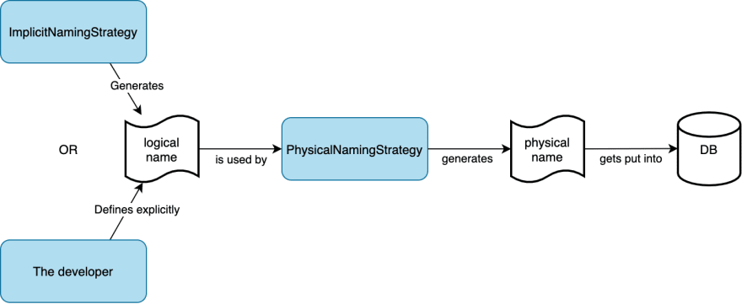

Hibernate default implementations of these interfaces are ImplicitNamingStrategyJpaCompliantImpl and PhysicalNamingStrategyStandardImpl. The former generates logical names in accordance with the JPA specification, and the latter uses them as physical names without any modifications.

Spring Boot overrides Hibernate default implementations for both interfaces and uses SpringImplicitNamingStrategy and SpringPhysicalNamingStrategy instead.